WHEREAS, Salisbury in the state of Maryland has a significant interest in the continued vitality of general aviation, aircraft manufacturing, aviation educational institutions, aviation organizations, and community airports; and
WHEREAS, general aviation and the Salisbury Airport have a significant economic impact on the City of Salisbury; and
WHEREAS, the 2018 Economic Impact of Public Use Airports in Maryland study found that general aviation airports in the state support annual business revenues of $867 million, more than 9,900 jobs, and a payroll of $582 million; and

WHEREAS, according to the Maryland Aviation Administration, the state has 35 public-use airports. These airports serve almost 9,400 pilots and almost 2,200 registered aircraft; and

WHEREAS, according to the FAA, the state is home to 27 repair stations, 13 FAA-approved pilot schools, almost 4,000 student pilots, and more than 1450 flight instructors; and

WHEREAS, general aviation not only supports Maryland’s economy, it improves overall quality of life by supporting emergency medical and healthcare services, law enforcement, firefighting, disaster relief, investments in sustainable fuels and technologies, and investments in innovative experimental technology like Vertical Takeoff and Landing vehicles, and by transporting business travelers to their destinations quickly and safely; and

WHEREAS, the United States faces a shortage of aviation professionals, leaders should invest in this critical infrastructure to ensure future economic growth and our next generation of aviation professionals and pilots;

NOW, THEREFORE, I, Randolph J. Taylor, Mayor of the City of Salisbury, do hereby proclaim May 2024 as

“GENERAL AVIATION APPRECIATION MONTH”

IN WITNESS THEREOF, I hereunto set my hand and the seal of the City of Salisbury this 17^{ht} day of April, 2024.

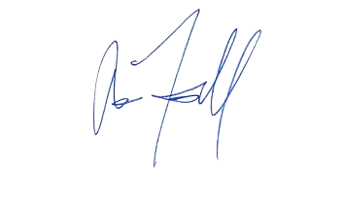
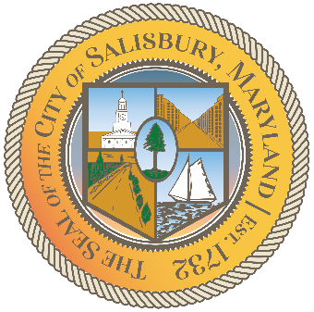

_____________________________________
Randolph J. Taylor, Mayor

